Walton Karl Avillanosa

UPV

CMSC 21-1

Basic Syntax in C

Lecture 1 Assignments

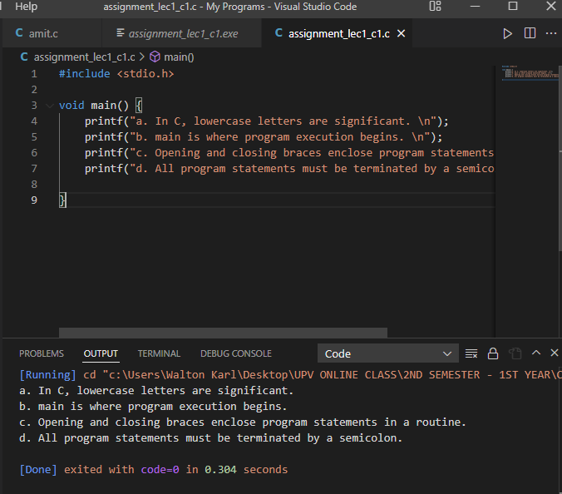1. Write a program that prints the following text at the terminal.

2. What output would you expect from the following program?

#include <stdio.h>

int main (void){

printf ("Testing...");

printf ("....1");

printf ("...2");

printf ("..3");

printf ("\n");

return 0;

}

> This will have an output of: “Testing.......1...2..3”

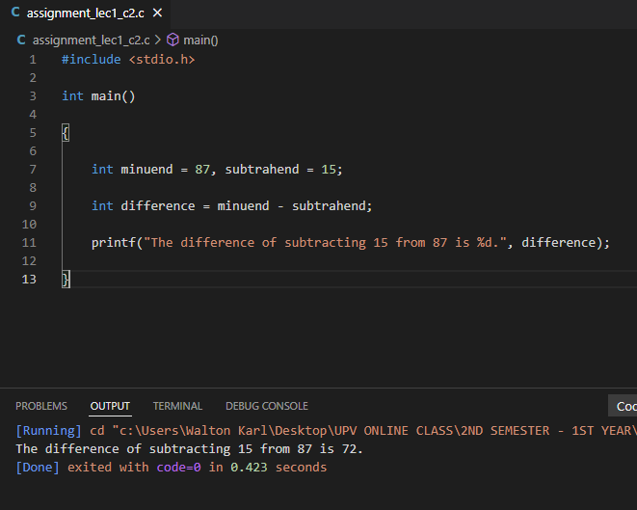3. Write a program that subtracts the value 15 from 87 and displays the result, together with an appropriate message, at the terminal.

4. Identify the syntactic errors in the following program. Then type in and run the corrected program to ensure you have correctly identified all the mistakes.

#include <stdio.h>

int main(Void)

INT sum;

/\* COMPUTE RESULT

sum = 25 + 37 - 19

/\* DISPLAY RESULTS //

printf ("The answer is %i\n" sum);

return 0;

}

> The syntactic errors are:

int main(Void), no “{“, INT sum; , and bad // and /\*…\*/ comment

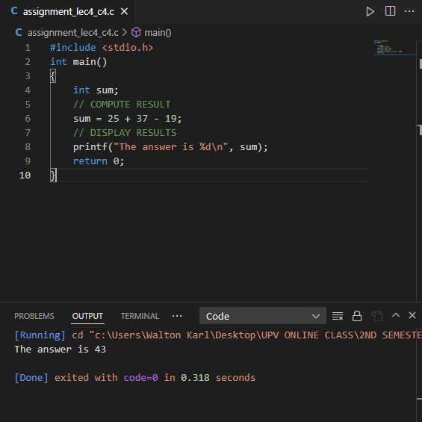

5. What output might you expect from the following program?

#include <stdio.h>

int main (void){

int answer, result;

answer = 100.

result = answer - 10;

printf ("The result is %i\n", result + 5);

return 0;

}

> The file will find an error with a “.” At the end of line 4, which is: “answer = 100.” Instead of a semicolon “;”